Practical No 25 & 26

VIII. Resources required (Additional)
→ If any web resources required.

Resources used (Additional)
https://www.tutorialspoint.com/vb.net/vb.net

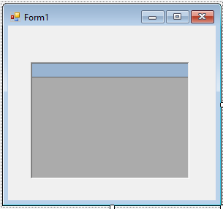Program Code
  - Write a program using data adapter to connect to the database.

Imports System.Data Imports System.Data.OleDb

Public Class Form1

Private Sub Form1_Load(sender As Object, e As EventArgs) Handles MyBase.Load Dim conn As New OleDbConnection("Provider=Microsoft.Jet.OLEDB.4.0;Data " &
"Source=C:\Users\Suresh\Documents\Visual Studio 2012 \ Projects \ Datagrid \ stud.mdb")
Conn.Open()
Dim cmd As New OleDbCommand("Select * From Marks", conn) Dim da As New OleDbDataAdapter(cmd)
Dim ds As New DataSet da.Fill(ds, "Marks") DataGrid1.CaptionText = "marks" DataGrid1.DataSource = ds DataGrid1.DataMember = "marks"

End Sub End Class

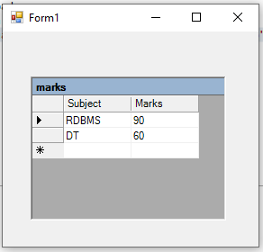Output:

Practical related Questions
  - Find error from following code
Dim adp As OleDbConnection("Provider=Microsoft.Jet.OLEDB.4.0DataSource=D:\mydata.accdb;")

Error 1 Type expected.
Error 2 'OleDbConnection' is a type and cannot be used as an expression. Error 3 'Conn' is not declared. It may be inaccessible due to its protection level.

  - Write a data adapter syntax using a MS-access code with a student table.
- Dim da As OleDbDataAdapter Da=New OleDbDataAdapter(cmd)

ercise
  - Design the windows application in MS-Access which have navigation (Next, First, Previous, Last).
➢
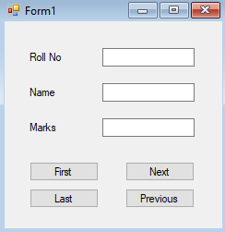

Imports System.Data.OleDb Public Class Form1
Dim con As OleDbConnection Dim ds As New DataSet
Dim cmd As OleDbCommand Dim da As OleDbDataAdapter
Private Sub Form1_Load(sender As Object, e As EventArgs) Handles MyBase.Load 'TODO: This line of code loads data into the 'Db1DataSet.student' table. You can
move, or remove it, as needed.
End Sub
Me.StudentTableAdapter.Fill(Me.Db1DataSet.student)
con = New OleDbConnection("Provider=Microsoft.Jet.OLEDB.4.0;Data Source=C:\Users\Suresh\Documents\Visual Studio 2012\Projects\Nav2\db1.mdb")
con.Open()
cmd = New OleDbCommand("Select * From student", con) da = New OleDbDataAdapter(cmd)
da.Fill(ds, "student")
Me.TextBox1.DataBindings.Add("text", ds, "student.RollNo") Me.TextBox2.DataBindings.Add("text", ds, "student.Name") Me.TextBox3.DataBindings.Add("text", ds, "student.Marks")
Private Sub Button1_Click(sender As Object, e As EventArgs) Handles Button1.Click
Me.BindingContext(ds, "student").Position = 0 End Sub

Private Sub Button2_Click(sender As Object, e As EventArgs) Handles Button2.Click Me.BindingContext(ds, "student").Position = Me.BindingContext(ds,
"student").Position + 1 End Sub

Private Sub Button3_Click(sender As Object, e As EventArgs) Handles Button3.Click Me.BindingContext(ds, "student").Position = Me.BindingContext(ds,
"student").Position - 1

End Sub

Private Sub Button4_Click(sender As Object, e As EventArgs) Handles Button4.Click Me.BindingContext(ds, "student").Position=Me.BindingContext(ds,"student").Count-1
End Sub End Class OUTPUT:
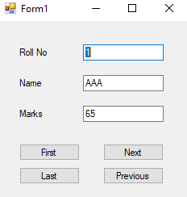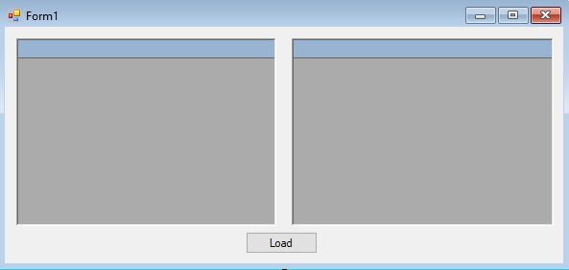
2. Develop a windows application that will contain multiple tables in a single dataset.
➢
Imports System.Data.OleDb
Public Class Form1
Dim con As OleDbConnection Dim ds As New DataSet
Dim cmd As OleDbCommand Dim da As OleDbDataAdapter
Private Sub Button1_Click(sender As Object, e As EventArgs) Handles Button1.Click
Dim con As New OleDbConnection("Provider=Microsoft.Jet.OLEDB.4.0;Data Source=C:\Users\Suresh\Documents\Visual Studio 2012\Projects\Multiple Table\db1.mdb")
con.Open()

Dim cmd1 As New OleDbCommand("Select * From student", con)

Dim cmd2 As New OleDbCommand("Select * From subjects", con)

Dim da1 As New OleDbDataAdapter(cmd1) Dim da2 As New OleDbDataAdapter(cmd2)

Dim ds As New DataSet

DataGrid1.CaptionText = "Student Record" DataGrid2.CaptionText = "Subject Details"

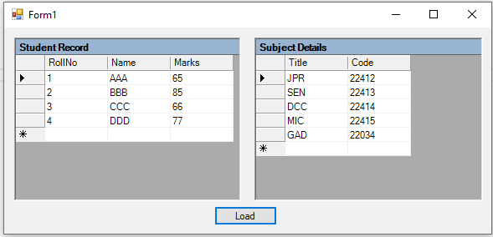

da1.Fill(ds, "student") da2.Fill(ds, "subjects")

DataGrid1.DataSource = ds DataGrid1.DataMember = "student"

DataGrid2.DataSource = ds DataGrid2.DataMember = "subjects"
End Sub End Class
OUTPUT:

